ULTRASONIC TREATMENT EFFECTS ON CuS_{1.8} – CdSe STRUCTURES
Oleg Olikh, Bogdan Polonsky
Taras Shevchenko National University of Kyiv, Kyiv, Ukraine
phone: +380445260510, e-mail: olikh@univ.kiev.ua
Ultrasound (US) is established to affect properties of II-VI semiconductors^{1,2}. However to the best of our knowledge, there have not reports on US influence on II-VI–based solar cells, whereas similar effects are detected in other barrier structures³. Our work has focused on the modification by US treatment (UST) of electrical properties of CuS_{1.8} – CdSe thin film photodetector. The longitudinal waves (8.4 MHz) were used for UST. The current-voltage (I-V) characteristics were measured over a temperature range 290-340 K both before and after UST. The ﬁtting were done by using differential evolution method.
The following expression, which is expected for recombination–tunneling currents in the investigated strusture⁴, is used for a forward I-V characteristics fitting:
, (1)
where 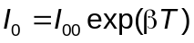 is the saturation current, R_{s} and R_{sh} are the series and shunt resistances, the factor α does not depend on the voltage. The extracted temperature dependences of parameters are shown in Fig. 1. In particular, it was ascertained, that R_{s} is thermoactivated (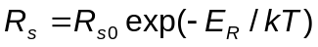) and R_{sh} is described by dislocation–induced impedance theory⁵. It was found out that UST had led to change of α, β, and R_{s} as well as R_{sh} activation energy. The sample room temperature (RT) storage results in complete recovery of both α and R_{SH} value, but acoustically induced (AI) residual both series resistance increase and saturation current decrease are observed.
The analysis has shown that reverse branch of I-V characteristics is determined by trap-assisted tunneling (TAT) at low bias (V > -0.8 V) and by trap-charge limited current (TCLC), which is induced by energetically exponentially distributed defects, at high bias (V < -2.5 V). The TAT current can be described⁶ as
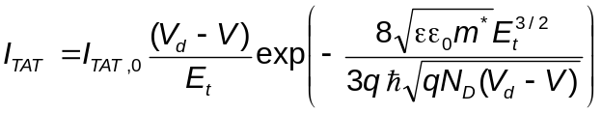, (2)
where I_{TAT,0} is proportional to the trap density, V_{d} is the built in voltage due to the band bending, E_{t} is the position of the trap in the band gap, the N_{d} and ε are the donor density and the dielectric constant of CdSe. The power low
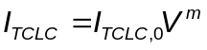 (3)
was used to TCLC current fitting. In this case⁷, power index m > 3 and (m - 1)=T_{c} / T, where T_{c} is the characteristic temperature parameter of the trap distribution and 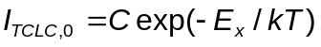, where E_{x} is the activation energy that deﬁnes a ﬁnite Fermi level with free-charge carriers being emitted from low-lying ﬁlled traps.
The results, which are obtained from the reverse I-V characteristics, are shown in Fig. 2. As one can recognize, UST affects the energy characteristics of defects, which located both in space charge region (see Fig.2(a,b)) and in diode base (see Fig.2(c,d)). Thus E_{x} had decreased from 0.48 eV to 0.28 eV after UST immediately and E_{t} had risen by 0.1 eV at same conditions. AI defect system disturbance disappears in p-n region practically completely and in the quasi-neutral region partly after RT storage.
On our opinion, the observed effects deal with the AI defect generation.

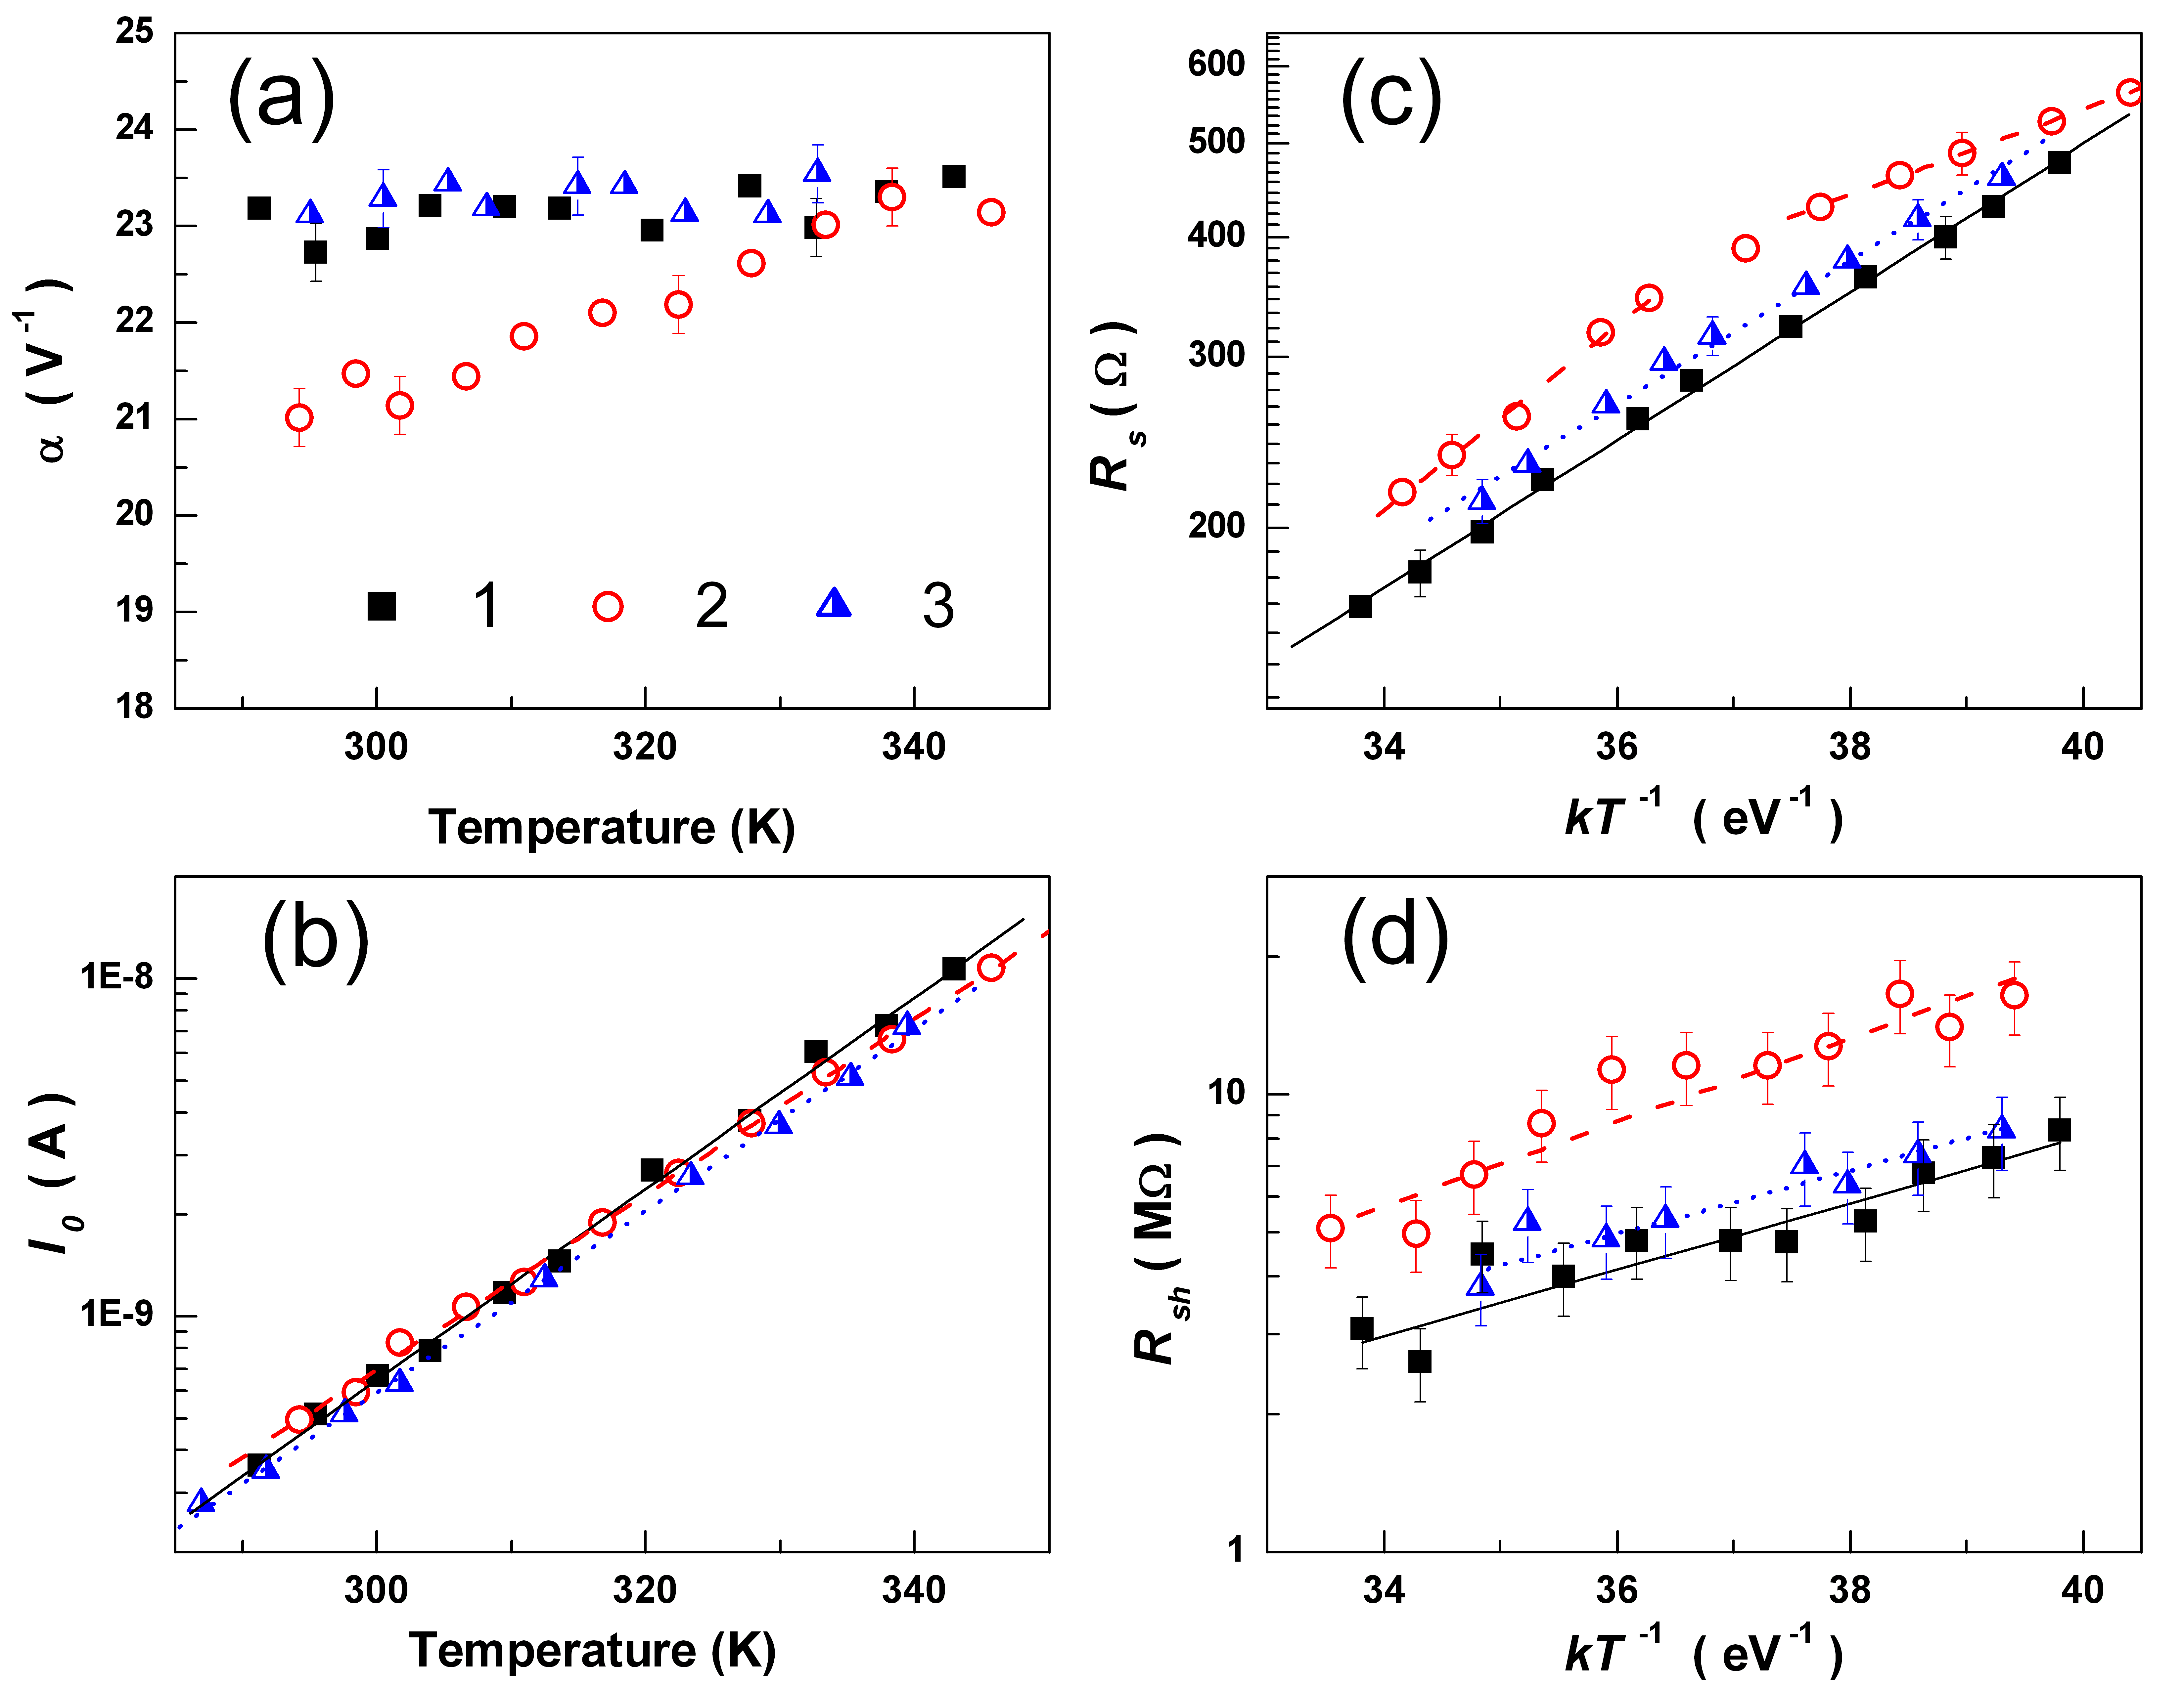
Figure 1. Temperature dependencies of parameters, which were determined from forward I-V characteristics. The measurements were taken before UST (curves 1, squares), immediately after UST (curves 2, circles), and after UST and ~75 h RT storage (curves 3, triangles).
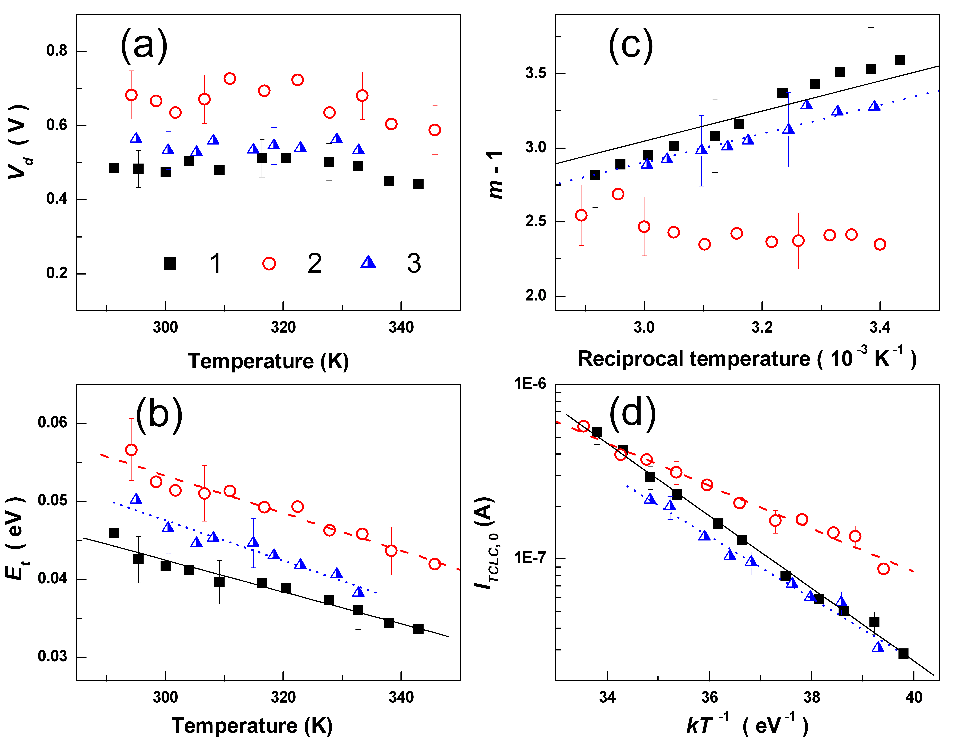
Figure 2. Temperature dependencies of TAT (a, b) and TLCL (c, d) parameters. The measurements were taken before UST (curves 1, squares), immediately after UST (curves 2, circles), and after UST and ~75 h RT storage (curves 3, triangles).
1. R. Savkina, A. Smirnov, and F. Sizov, Semicond. Sci. Technol. 22, 2007, 97.
2. M. Sheinkman et al., Mat. Sci. Forum 196-201, 1995, 1467.
3. O. Olikh, K. Voytenko, and R. Burbelo, J. Appl. Phys. 117, 2015, 044505.
4. S. Yu. Pavelets et al., Semiconductors 35, 2001, 605.
5. V. Gopal and S. Gupta, IEEE Trans. Electron Devices 51, 2004, 1078.
6. V. Gopal, S. K. Singh, and R. M. Mehra, Semicond. Sci. Technol. 16, 2001, 372.
7. M.M. Abdul-Gader Jafar, Semicond. Sci. Technol. 18, 2003, 7.
Figure. Temperature dependencies of tunneling parameter 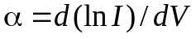 (a), series resistance (b) and barrier height (c). The measurements were taken before UST (curves 1, squares), immediately after UST (curves 2, circles), and after UST and ~75 h room temperature storage (curves 3, triangles).

